Name – Jay Sandeep Chatpalliwar

PRN – 21510018

Assignment 10 – Digital Signatures

1]Aim:

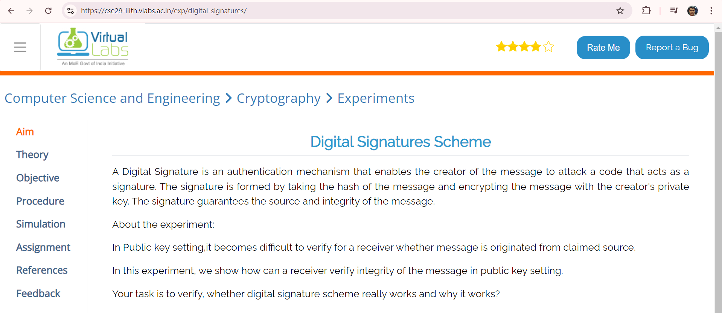

2]Objective: To understand "How and Why Digital signature schemes?"

3]Procedure:  
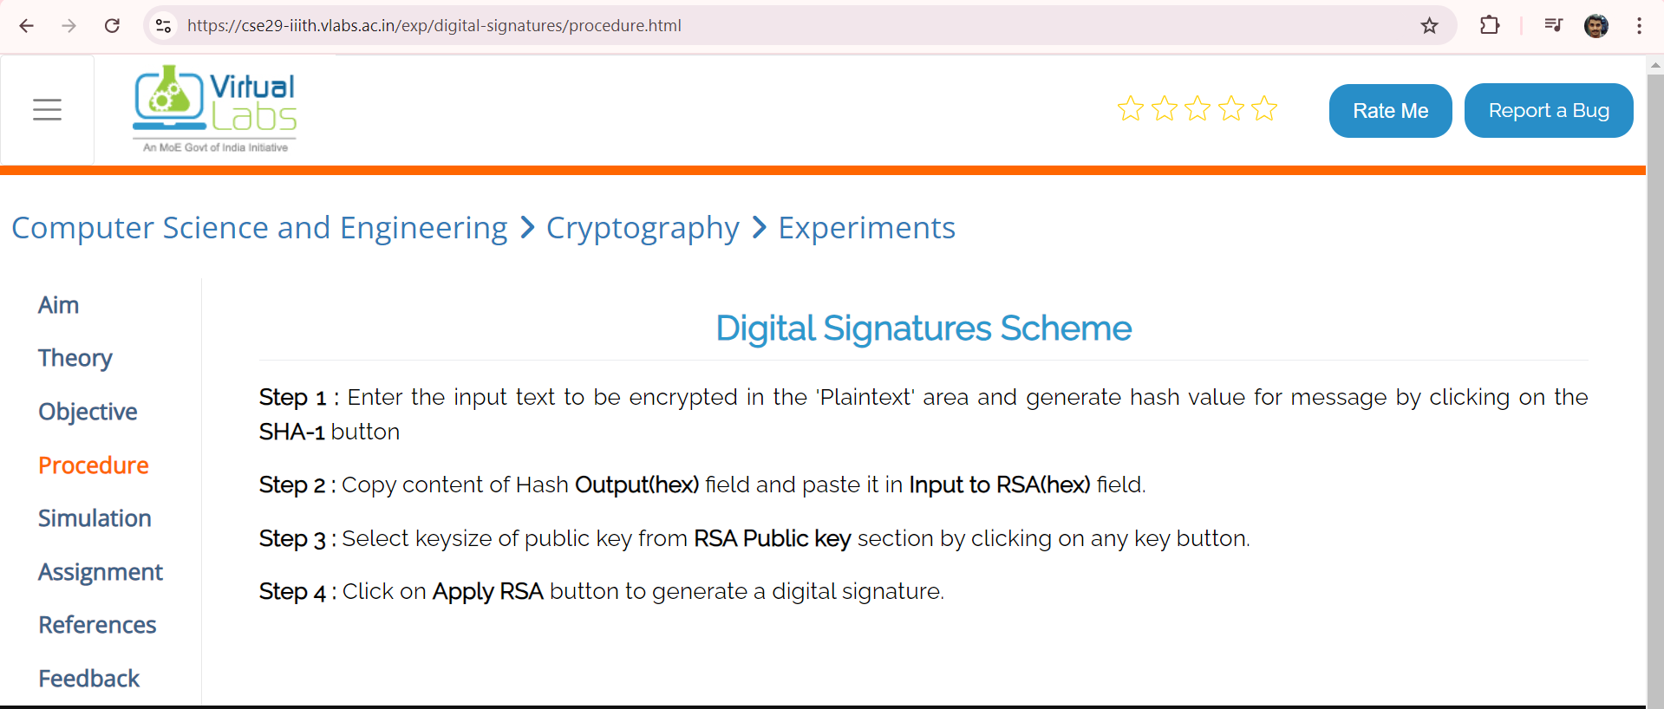

4]Simulation:

